Retail Sales Data Analysis using SQL and Power BI

Created by:
Deepak Sharma

1. INTRODUCTION
Retail businesses generate large volumes of sales data that can be analyzed to understand customer behavior, product performance, and seasonal trends.
This project focuses on analyzing retail sales data using SQL for querying and Power BI for visualization to derive meaningful business insights.

2. PROBLEM STATEMENT
The objective of this project is to analyze retail sales data in order to:
- Identify top-performing product categories
- Understand customer demographics
- Analyze sales trends over time
- Provide data-driven business recommendations

3. DATASET DESCRIPTION
- Dataset Name: Retail Sales Dataset
- Number of Records: 1000
- Key Columns:
  - Transaction ID
  - Date
  - Product Category
  - Gender
  - Age
  - Total Amount
The dataset represents transaction-level retail sales data.
4. TOOLS & TECHNOLOGIES USED
- MySQL: For data querying and analysis
- Power BI: For data visualization and dashboard creation
- Microsoft Word: For documentation

5. SQL ANALYSIS
This section includes important SQL queries and findings.
5.1 Total Number of Transactions
- Total observations: 1000
5.2 Sales by Product Category
- Electronics generates the highest total revenue.
- Beauty contributes the lowest total revenue.
5.3 Orders by Category
- Clothing has the highest number of orders.
- Beauty has the lowest number of orders.
5.4 Gender-wise Sales
- Female customers contribute more to total sales than male customers.
5.5 Age-group Analysis
- Customers above 50 years generate the highest revenue.
- Age group 20–30 shows strong purchasing activity.
5.6 Time-based Analysis
- Sales peak during May and October.
- Seasonal and festive trends significantly impact sales.
5.7 Average Order Value (AOV)
- Beauty category shows the highest average order value, indicating premium purchases.

6. POWER BI DASHBOARD
The Power BI dashboard visualizes:
- Category-wise sales
- Monthly sales trends
- Age and gender distribution
- Measures like Totalsales , Total categories sales . Filters like product category and quantity .
The dashboard helps in quick decision-making through interactive visuals.
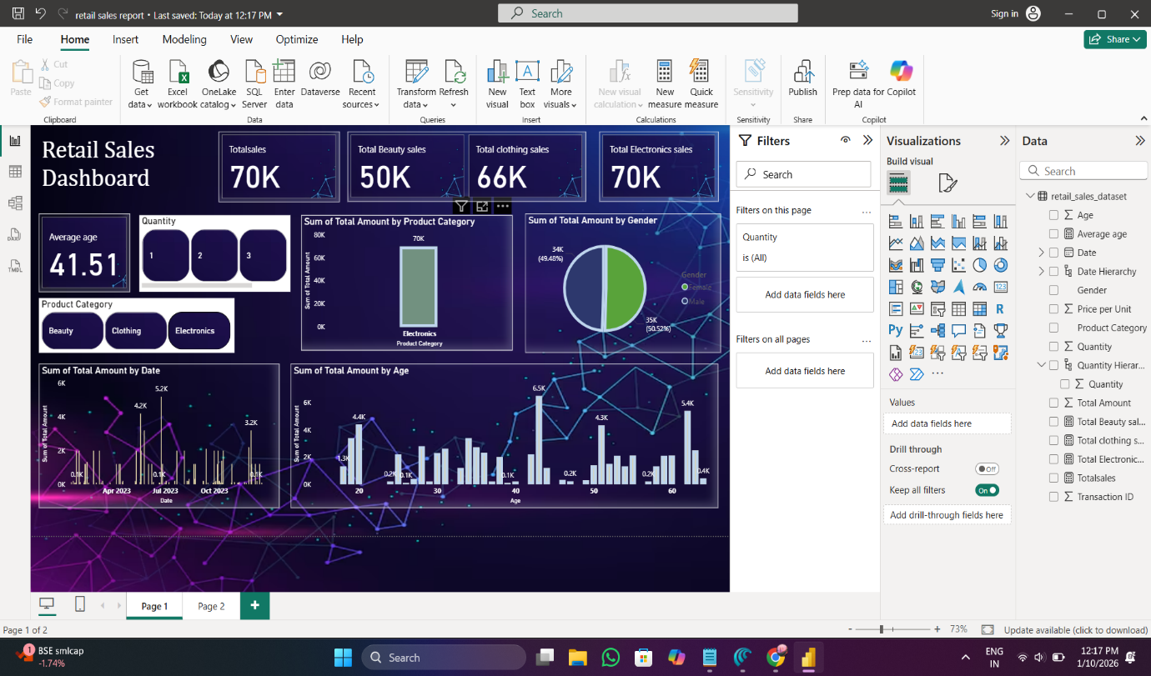

7. KEY INSIGHTS & RECOMMENDATIONS
Key Insights
- Customers aged above 50 are the highest revenue contributors.
- Beauty products have the highest average order value.
- Electronics leads in total revenue, while Clothing leads in order volume.
- Sales peak during festive and seasonal months such as October and May.
Recommendations
- Target customers above 50 with premium products.
- Promote beauty bundles and premium cosmetics.
- Plan festive marketing campaigns during Diwali and year-end.
- Offer discounts to 20–30 age group to increase purchase frequency.

8. CONCLUSION
This project successfully analyzed retail sales data using SQL and Power BI.
The analysis identified key customer segments, product performance, and seasonal trends, providing actionable business insights for improving sales strategies.

9. LIMITATIONS
- Dataset size is limited.
- Profit and cost data is not available.
- No geographical information is included.
10. REFERENCES
- SQL Documentation
- Power BI Official Documentation

